Kafka Setup (Your System, KRaft Mode)
BEFORE THIS:
Install Docker Desktop
Download from https://www.docker.com/products/docker-desktop
Install Docker Desktop for Windows
Enable WSL2 backend during installation
Restart your system after installation
START ON THESE:
- Project folder
  - Create: C:\Users\User\kafka-project
  - Place the docker-compose.yml file inside.
  - Your YAML uses the official apache/kafka:latest image with KRaft configuration.
- Start Kafka container
  - Open PowerShell or Command Prompt.
  - Navigate to the folder:
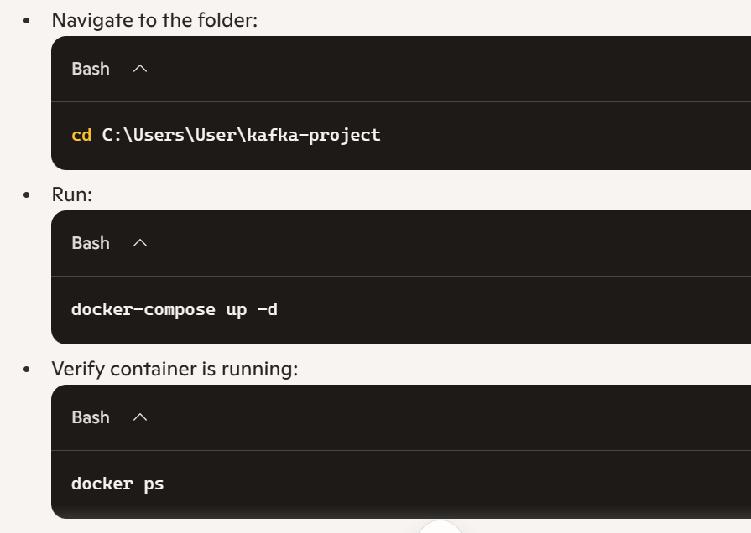
- Access Kafka container
  - Enter the container:
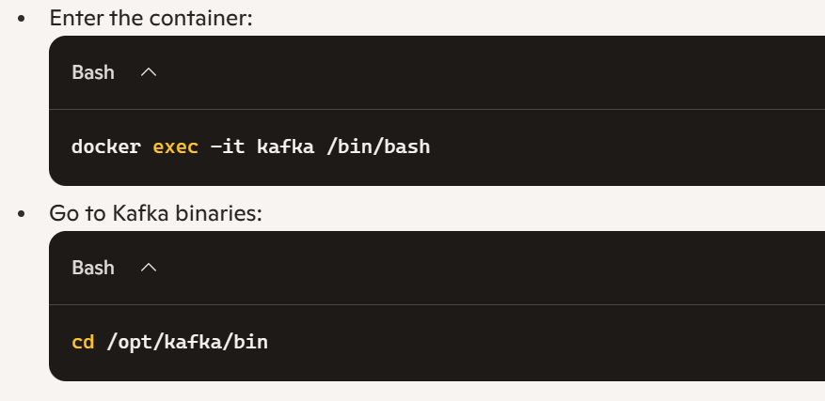
- Create a topic
Inside the container:
./kafka-topics.sh --create --topic test-topic --bootstrap-server localhost:9092 --partitions 1 --replication-factor 1
Verify
./kafka-topics.sh --list --bootstrap-server localhost:9092

- Test producer & consumer (CLI)
  - Producer:
./kafka-console-producer.sh --topic test-topic --bootstrap-server localhost:9092
Type a message → press Enter.
  - Consumer:
./kafka-console-consumer.sh --topic test-topic --bootstrap-server localhost:9092 --from-beginning
You should see the message echoed.
- Connect Jupyter Notebook (Anaconda)
Install client:
!pip install kafka-python
Producer and consumer code given in GIT
Use these two files .. RUN the producer first and then consumer .

